ASSIGNMNET – 4 [07-12-2023]

BY Karthikeyan K R

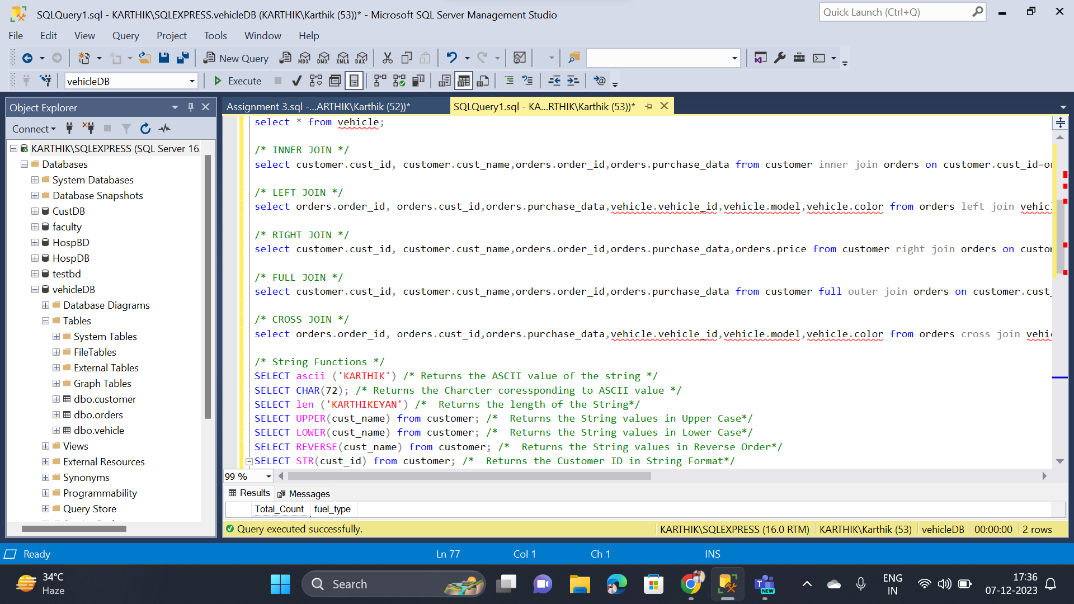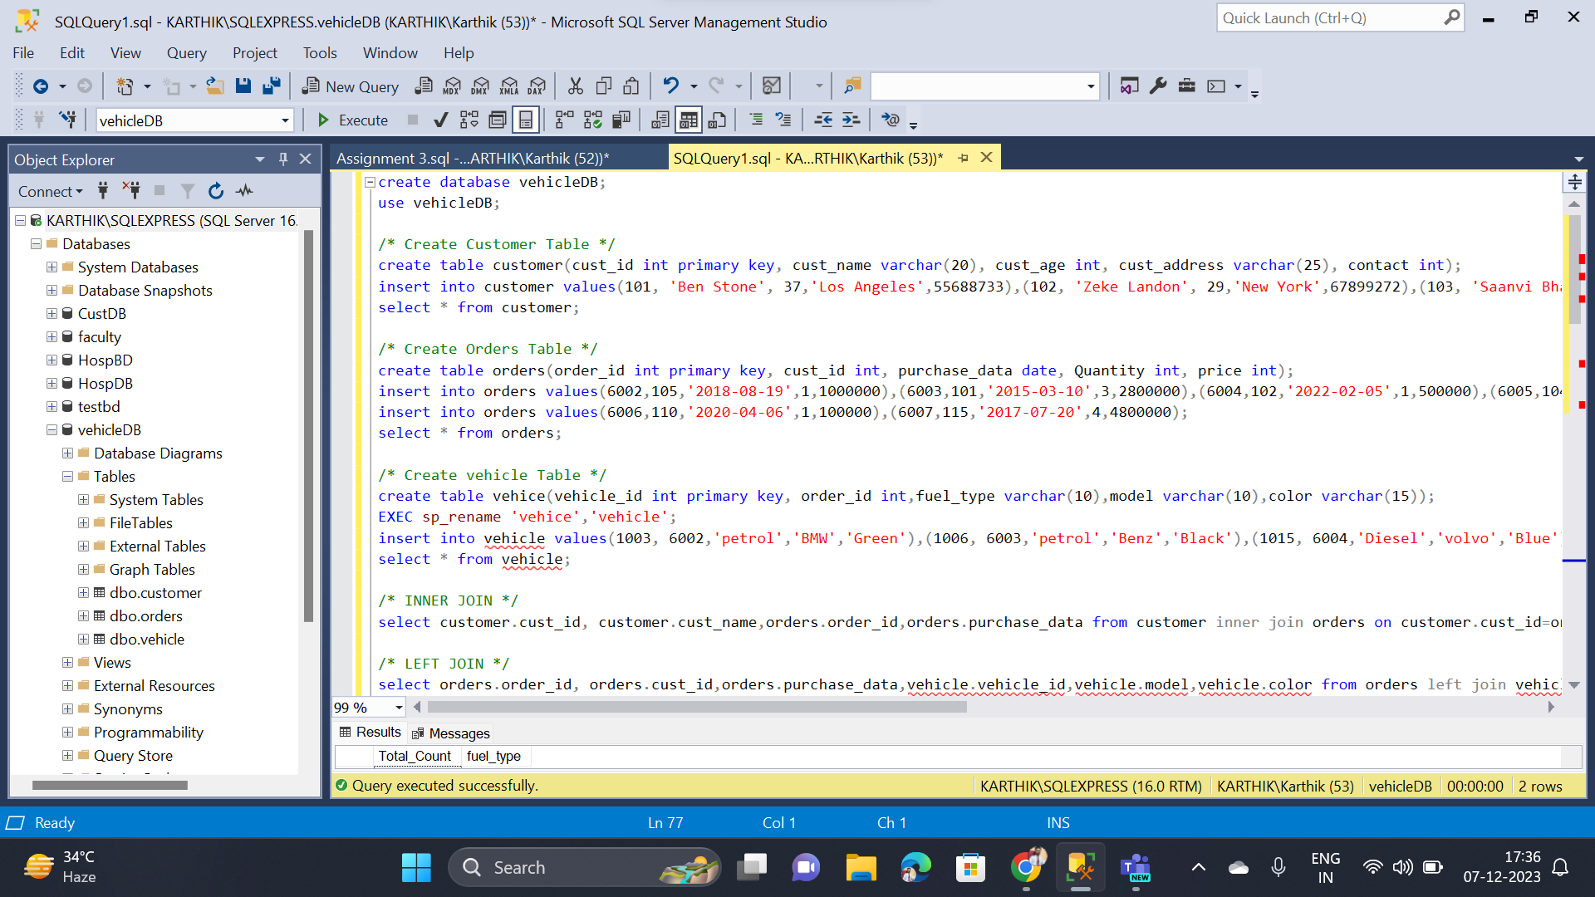

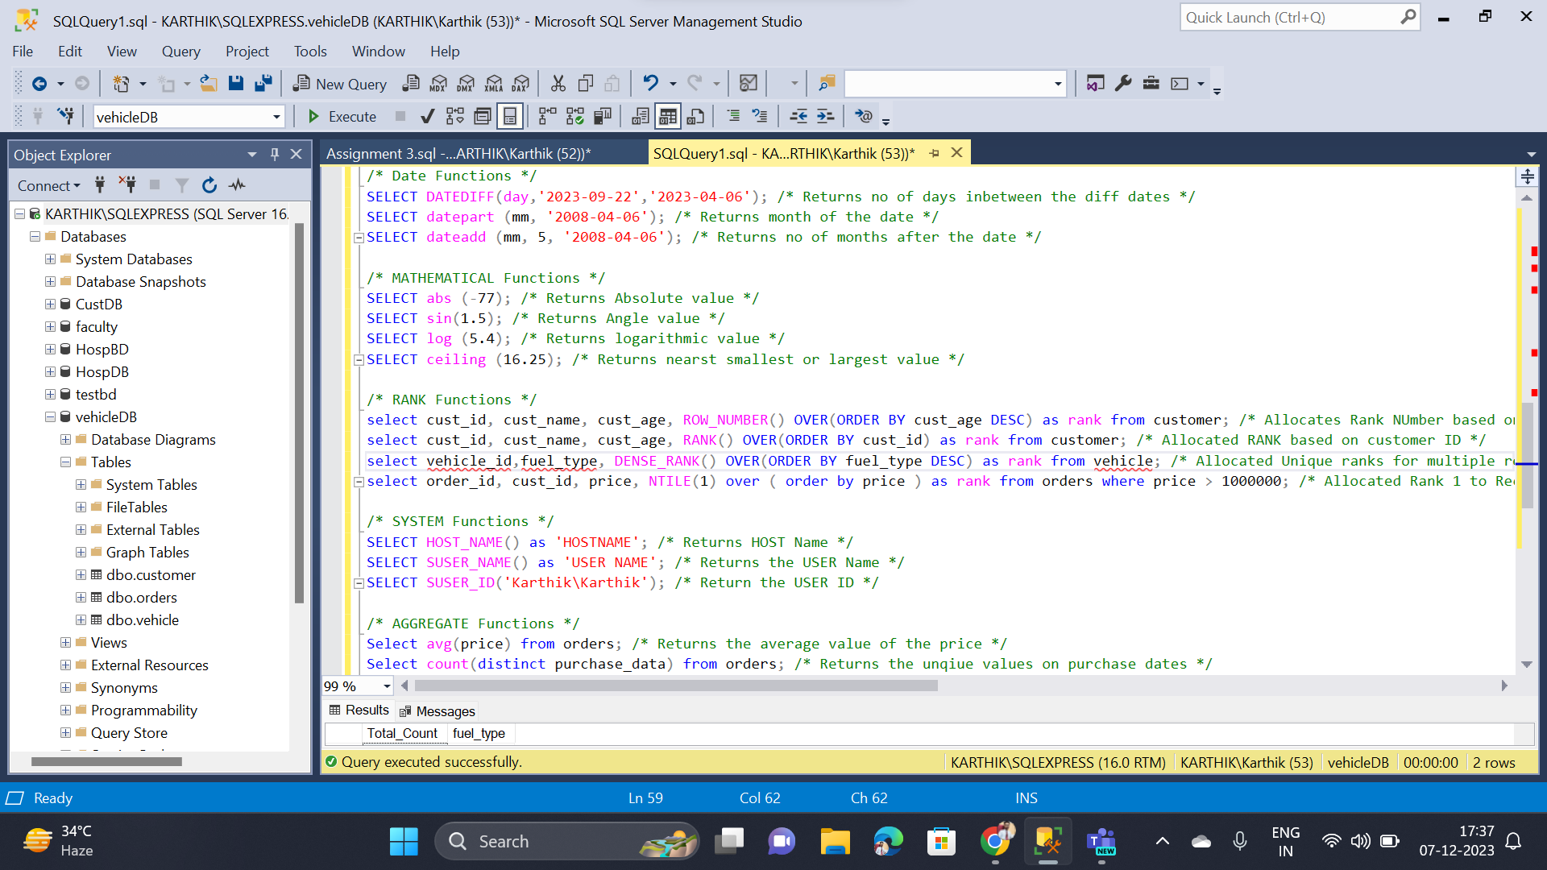

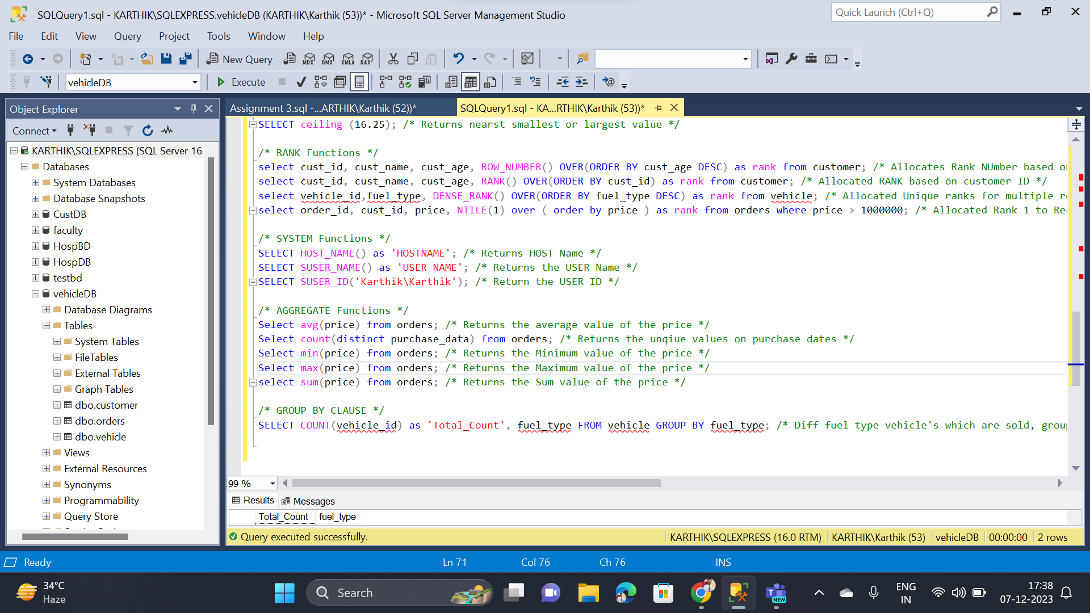

* Completed Different types of Joins
* Completed String functions
* Completed Date functions
* Completed Mathematical functions
* Completed Rank functions
* Completed System functions
* Completed Aggregate functions
* Completed Group by Clause